Title |  | First  Name | Dr. Muskaan | Last  Name |  | Photograph
Designation | Assistant Professor |  |  |  |  | 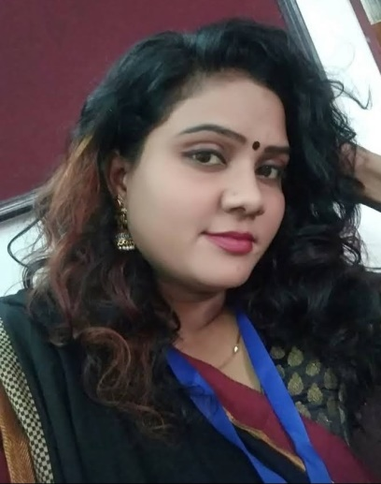
Address  (Campus)  (Residence) | Vivekanand College, DU
Phone No.  (Office) | 8860351924
(Residence)
Mobile
Fax
Email | muskaaneversmiling@gmail.com
Web-Page
Educational Qualifications | B.A, M.A., M.Phil., Ph.D. From Delhi University  Qualified UGC NET-JRF in first attempt (Appearing)
Degree | Institution |  |  |  | Year
Ph.D. awarded in 2021 | Delhi University |  |  |  | 2021
Career Profile
Designation |  |  |  |  | Duration
Assistant Professor |  |  |  |  | 8 Years
Administrative Assignments- Currently working as Teacher-in-Charge of Political Science Department , Vivekananda College. Also working as an active member of Examination Committee, Vivekananda College. Simultaneously Working as a member of Internal Complaint Committee (ICC), Vivekananda College.

Subjects Taught- Political Theory, Feminism, Indian Govt. and Politics, Political Thought

Research Guidance:

Publications profile: 1 Book published on women in Displacement ‘ Bezameen Hoti Aurten’ Several research papers and articles have been published in reputed research journals and newspapers.

Conference organization/Presentations (in the last three years): Presented paper in International Conference organized by Vivekananda College. Participated in many National Seminars organized by Delhi University’s colleges (Kirori Mal College). Participated and Faculty Development Program (FDP) organized by Maitreyi College of Delhi University.

Research Projects (Major Grants/Research Collaboration)

Awards and Distinctions:

Other Activities – Every year in the month of March I used to organize an event called ‘APARAJITA’ to promote girls students in every sphere of life. The motive of this yearly event is to make girl students more confident, rational as well as employable.

